

***Last printed Issue >>>***

Issue

*Spreading the Love*

*Holding on to the familiar and having faith in it…*

*Building the Trust!*

A child’s worst nightmare is being separated from the one person they have been connected to since birth.



Perhaps planning a family outing or a fun night at home together will help break the ice and ease the transition. Try connecting with a support group as a caregiver and sharing ideas with others who share your story. Maybe attend a kinship event where the entire family can see they are not on this road alone. Find your way to spread the love and build the trust!

Understanding these key elements will be a work in progress for everyone in the home and they will all need to take the time to adjust and make room in their minds and hearts for an additional member.

The building blocks of any family dynamic center around a foundation of love and trust.

***Ground hogs day Feb 2nd***

*Please email* [*nelsonk@alconaseniors.org*](mailto:nelsonk@alconaseniors.org) *if you do not have access to a computer and would like your newsletter mailed to you! –Kristie*

rules. Be mindful of what you first expect out them as they will need time to adjust to the changes and the new environment all together.You must also make changes and allow yourself to spread the love to include them and give to them the same measure of love and affection that you provide to your own children.

It is easy to think that because you are family they will easily fall into place with you and your immediate family, but they have never been a part of your routine,or been raised under your

**Just the like the ground hog we wait to see every February, hoping that he will see his shadow and we will have an early spring, a young child grasps at the chance that the loved one who his taking them in will be someone they can count on, and their love and affection will be something they can believe in.**

**It is up to each one of us to not only take responsibility, but to be responsible. Understand that your love and affection is greatly needed and finding a trust in you is vital.**

*The building blocks of any family dynamic center around a foundation of love and trust.*



**Kinship Support Group – a place to build relationships and realize you are not alone….Feb 19 - 1pm**

*Kinship is key*

**FEB25 @%**

**25**

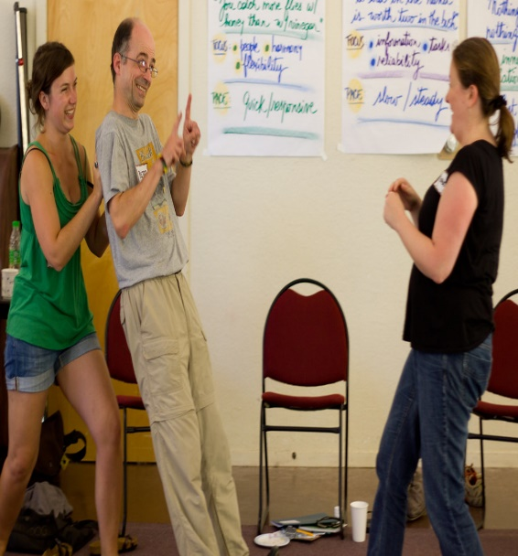

***Trust Exercises***

*Looking for a place to connect with others who share your story? Yearning for someone to listen, to understand your struggles, to offer some personal tips for making things easier? Come out to the ACCOA February 20th at 5pm!*

***Building Trust in Each Other***



The one constant in all of our lives, is how busy we are. The days fly by and suddenly your little babies are grown adults and are busily making lives of their own. You and your loved ones have missed an entire lifetime of opportunity to enjoy life with one another. Your soul focus has been on work and maintaining a lifestyle and you have lost focus on what truly matters in the world, your family. Stop and make time, before its too late!

*The greatest gift you can give to your family and the ones you love is Time!*

*The Perfect Gift! !*

I know what each of you are experiencing. I share your story and that is why I love what I do for a living. I love helping all of you.

I can share with all of you what has helped me to make it through the rough moments and I know how wonderful it was to have someone in my corner.

Lets come together and build a Kinship family we can all count on!

***Kinship Kinnection***

Trust exercises are activities designed to build trust within a group by requiring individuals to rely on each other.

often involving scenarios where one person needs to put their faith in others, such as "Trust Falls" where someone falls backwards into the arms of others, "Human Knot" where a group needs to untangle themselves while holding hands, or "Blindfolded Obstacle Course" where someone navigates a course while blindfolded and guided by others.

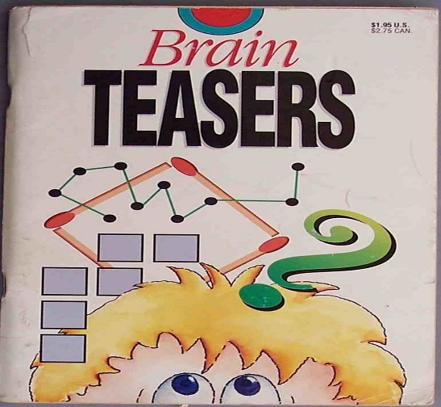

*Game time!!!!*

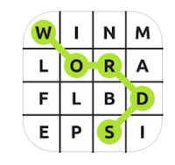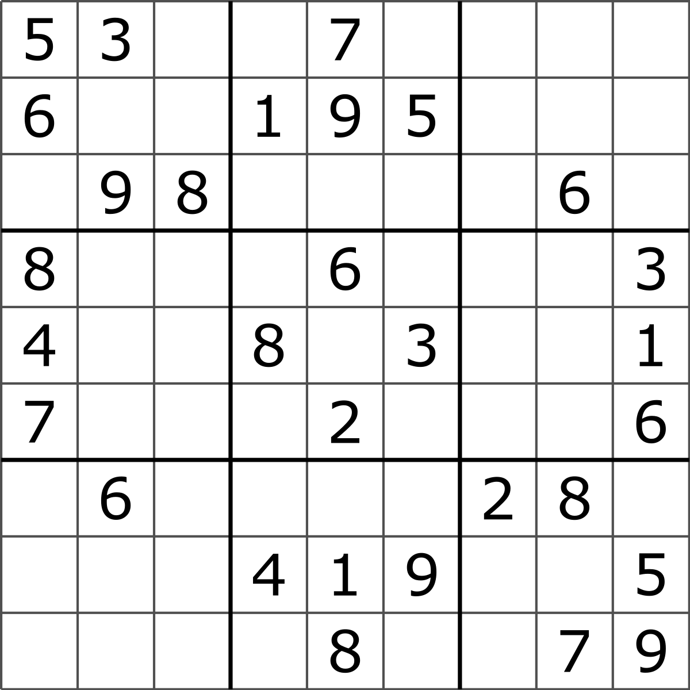

**How**

**Many**

**Words**

**can**

**you find?**

*Agatha’s mother has three daughters. One is named Danielle, another is named Brittany. What is the name of the third daughter?*

. A =1

C =2

E =5

THEN

B x D X A = ?

*What can you catch but not throw?*

*.****I can fly but I have no wings, I can cry but I have no eyes, What am I ?***

***See next addition for answers***



***Coming Soon….***

***thoughts...***

*finall*

***We are steps into the New Year and I am super exciting to add new faces to our Kinship Family.***

***Don’t miss out on your two opportunites this fiscal year for Kinship funding!!***

*Finding An Agent That’s Right For You*

February is not just Valentines month it’s a whole host of national awareness and prevention rememberances to consider.

Lets take a moment this month and remember the loved ones we lost and those that are still suffering at the hands of cancer or a congenital heart defect. If you haven’t yet, make a donation towards finding a cure and say a prayer for your loved ones and all loved ones out there fighting to live a



***St Paddy’s Day***

***Best o’ Luck to Ya’***

*Stop in and Spin the Wheel for a chance to claim a prize!*

*1 spin per Family*

***March 2025***

**Presidents day - February 17th 2025**

